Day 1 Assignment:
3) Write a blog about objects and its internal representation in Javascript ?
Objects, in JavaScript, is it’s most important data-type and forms the building blocks for modern JavaScript. These objects are quite different from JavaScript’s primitive data-types(Number, String, Boolean, null, undefined and symbol) in the sense that while these primitive data-types all store a single value each (depending on their types).
Objects are more complex and each object may contain any combination of these primitive data-types as well as reference data-types.
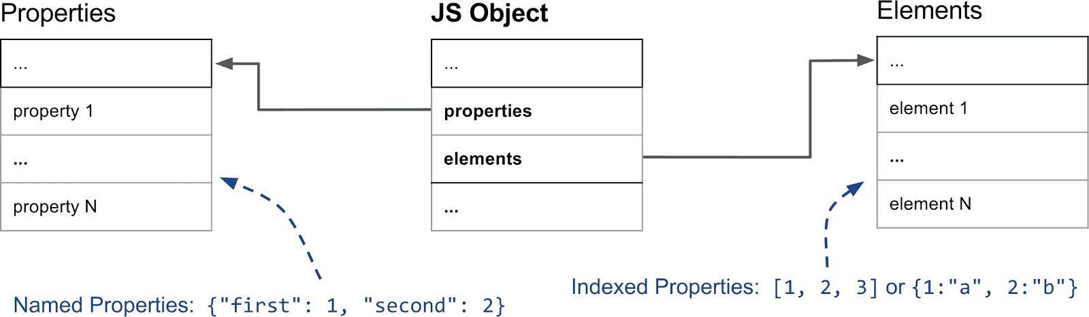
An object, is a reference data type. Variables that are assigned a reference value are given a reference or a pointer to that value. That reference or pointer points to the location in memory where the object is stored. The variables don’t actually store the value.
Objects in JavaScript may be defined as an unordered collection of related data, of primitive or reference types, in the form of “key: value” pairs. These keys can be variables or functions and are called properties and methods, respectively, in the context of an object.
In simple terms “A JavaScript object is a collection of named values having state and behavior (properties and methods)”.
For example: Person, Car, Pen, Bike, Personal Computer, Washing Machine etc.
Here let’s take the case of cars. All cars have the same properties, but the property values differ from car to car. All cars have the same methods, but the methods are performed at different times.
Let’s have an example of my favorite Mercedes Car and list out its properties(Features):
- Make: Mercedes
- Model: C-Class
- Color: White
- Fuel: Diesel
- Weight: 850kg
- Mileage: 8Kmpl
- Rating: 4.5
Taking the above as reference, lets stress up on objects, their properties and methods.

1)Objects:
The following code assigns a simple value (Mercedes) to a variable named car:
var car = "Mercedes";
Objects are variables too. But objects can contain many values.
The following code assigns many values (Mercedes, C-class, White and so on) to a variable named Car:
var car = {Make: “Mercedes”, Model: “C-Class”, Color: “White”, Fuel: “Diesel”, Weight: “850kg”, Mileage: “8Kmpl”, Rating: “4.5”};
The values are written as name:value pairs (name and value separated by a colon).
Syntax:
var <object-name> = {key1: value1, key2: value2,... keyN: valueN};
So, conclusion and definition for JS objects is “JavaScript objects are containers for named values”.

2)Object Properties:
The name:values pairs (in JavaScript objects) are called properties.
var car = {Make: “Mercedes”, Model: “C-Class”, Color: “White”, Fuel: Diesel, Weight: “850kg”,Mileage: “8Kmpl”, Rating: 4.5};
From the above snippet, let’s have a look what falls under property and property value:
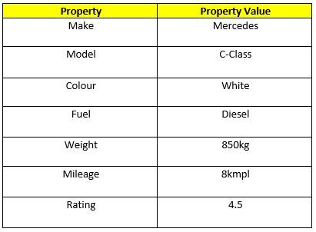
The object properties can be different primitive values, other objects and functions.
Properties can usually be changed, added, and deleted, but some are read only.

The syntax for adding a property to an object is :
ObjectName.ObjectProperty = propertyValue;
The syntax for deleting a property from an object is:
delete ObjectName.ObjectProperty;
The syntax to access a property from an object is:
objectName.property // Car.Make

//or

objectName["property”] // Car["Make"]

//or

objectName[expression] // x = "Make"; Car[x]
So, Conclusion and simple definition for Java Script properties is “Properties are the values associated with a JavaScript object”.

3)Object Methods:
An object method is an object property containing a function definition.
i.e.,..
Let’s assume to start the car there will be a mechanical functionality.
function(){return ignition.on}

and so similar is to stop/brake/headlights on & off, etc.
(I’m just trying to roll a picture in our mind. The car will not start / stop by means of code. I assume we would get it).
So, Conclusion and simple definition for Java Script Object methods is “Methods are actions that can be performed on objects.”.

